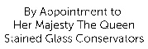

Condition report/conservation proposal

Location: Bubwith Almshouses, Wells- Medieval glass to the Chapel
North east window- small rectangular light 310 x 1230mm
Date of survey: 7th March 2019
Narrative:
Bubwith Almshouses were originally built in 1436, based on an endowment by Bishop Bubwith, carried out by his immediate successor John Stafford. The almshouses were later extended and improved. This glass, which is contemporary with the original foundation is the only surviving medieval glass in the Chapel. It contains (beginning at the base of the window) the arms of Sydenham/ Stourton, Stafford, Bubwith, and the Royal Arms.
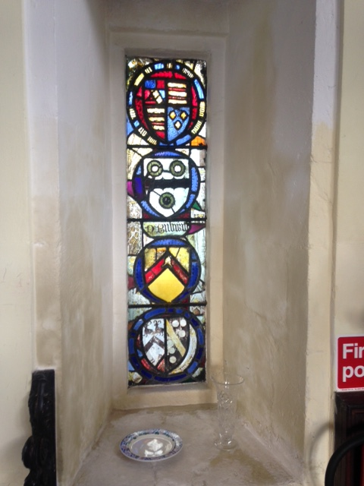
The surviving medieval stained glass is gathered in this window, although it had originally been elsewhere in the building.
Woodforde states that the heraldic shields were previously placed in the tracery sections of the east window, which now has more modern heraldic glass circa 1850 by Bell of Bristol, (relatively recently restored), which references this original glass. It is reasonable to assume that the glass was moved to its present position at that point.

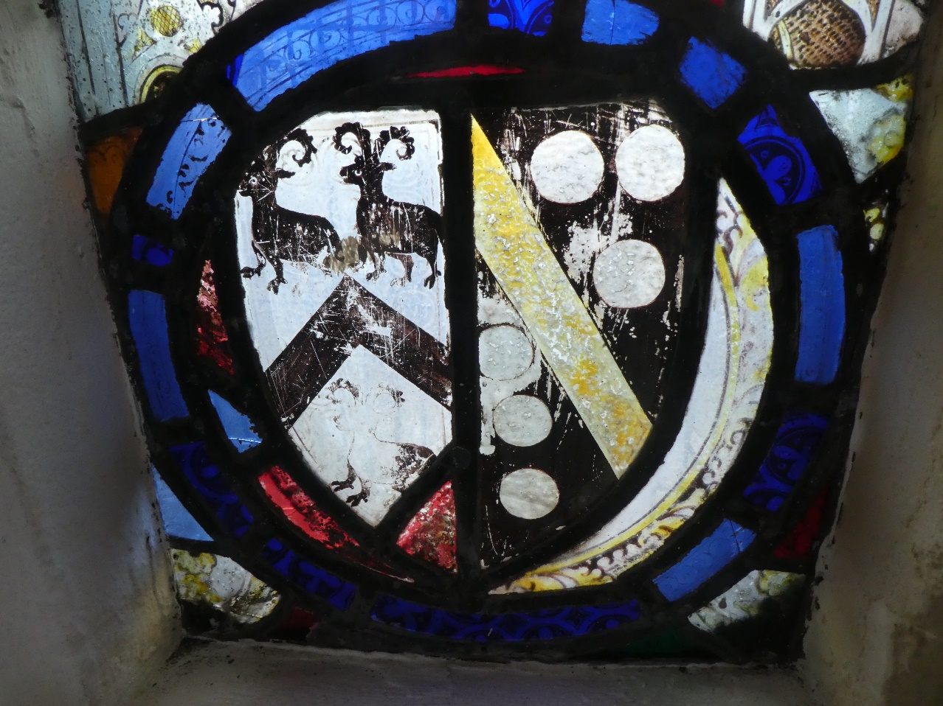
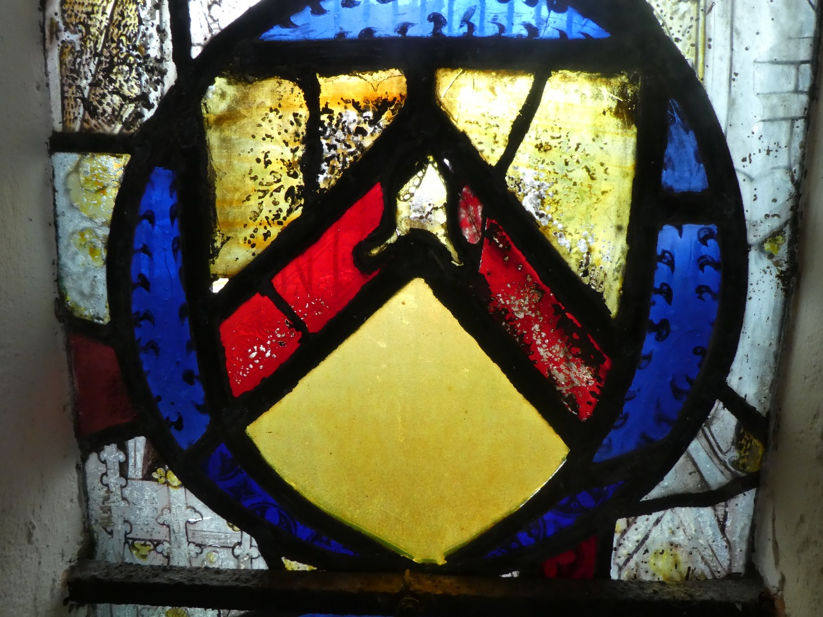

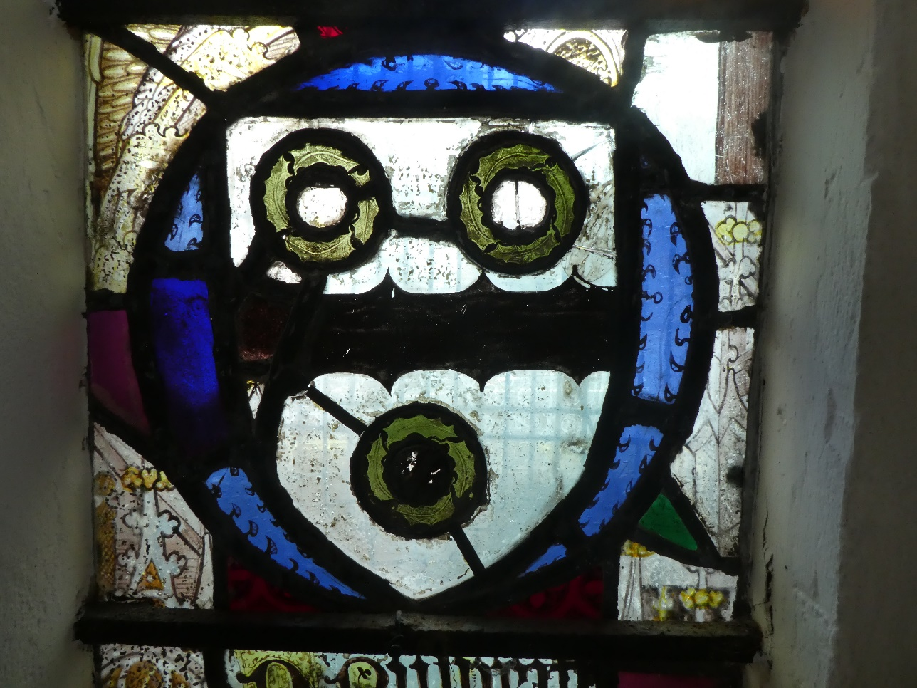
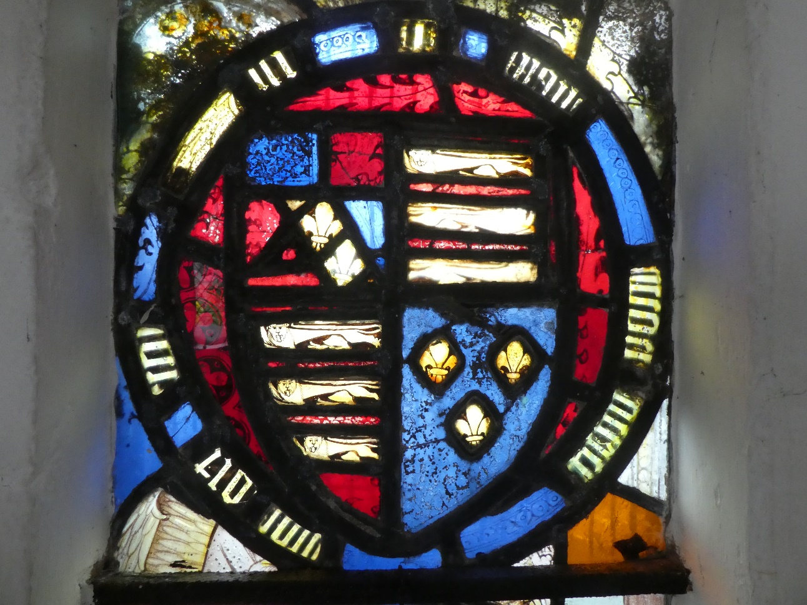

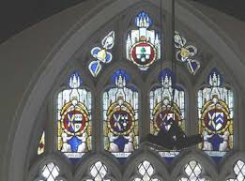
East window traceries
Description:
The heraldic devices are set on a ground of 15th century glass, which has the remains of angels, architectural canopy work, and rod and leaf border ornament. This is carried out in glass paint and silver stain, and is of very high quality. It is significant that the rod and leaf design neatly follows the circular forms of the earlier heraldic devices, which suggest that the original form had angels in niches holding the devices with rod and leaf decoration as an integral design element.
There are some insertions of unpainted purple, blue and green glass which date from the 19th century. The arms of Stafford has a large insertion of yellow stained glass, probably 19th century.
The shields themselves have some use of silver stain, but this is limited to- for example the bend on the dexter side of the lower arms (Stourton). The glass otherwise is largely pot metal glass with rich ruby and blue.
The window is set into stone reveals with hard cement based mortar, it has three internal ferrous tie bars ½ inch square section, each with a single central copper tie, which seem intact. The bars do not seem to be affecting adjacent stonework.
There is an external galvanised steel wire guard, which is necessary on the street side, but is very dirty, with a considerable build-up of debris at the base, which will hold moisture against the ancient glass, which is undesirable. (See appendix 3- Degradation of Glass).
The glass has corrosion pits on both faces, and some loss of painted detail, as well as surface abrasion. There is soma algal growth to the upper and lower edges on the internal face corresponding with debris trapped in the wire guard on the external face.

Condition:
Glass:
The glass is dirty on the internal face. There are a number of single cracks to the window, but the pieces of glass remain stable. The arms of Bubwith has a ground of holly leaves, there are several ugly historic repair leads, and fragments of glass are parted. This area needs some work to remove the repair leads and stabilise the fragments for aesthetic and structural improvement. However glass is not in danger of becoming dislodged at present.
There are also several other unsightly repair leads in the arms of Stafford
There is significant corrosion with pitting to the internal and external faces of the glass .This is fairly common in 15th century glass.

Painted Detail:
The condition of the painted detail is varied, but there is general slight paint loss. This general loss is almost certainly to do with cycles of condensation over the centuries. There are also areas which have been roughly handled with obvious abrasion- notable are the rams in the lower shield, and the Fleur de Lys in the Royal Arms.

Lead:
The lead is a rather heavy 3/8 inch flat section, not sympathetic to the delicacy of the work, but of historic significance itself as part of a 19th century restoration. It remains in reasonable condition, there is no justification for re- leading at present.
There are a few glints of daylight where stained glass cement has fallen away, or glass is ill-fitting, but this is easily remedied with the application of small areas of linseed oil putty stained with Lamb Black pigment.

Perimeter mortar:
Cement based mortar, quite hard. Remains intact.

Iron support structure:
Three internal ferrous tie bars ½ inch square section. Paint remains in reasonable condition. Do not appear to be rusting and spalling stonework.

Projected works: Condition/ Priority Code – C3
It would be sensible to clean, conserve and protect the glass to ensure its long term survival for the enjoyment of future generations. We suggest that the glass is cleaned, and minor repairs carried out in-situ.
A new protective external screen of glazing to be introduced, leaded into four sections to correspond to the positions of the tie bars. This should be made of toughened glass, mounted into a slender bronze frame held in place with discrete screw fixings, and grouted with lime mortar at the perimeter. This layer could then be removed periodically (say every decade) for cleaning and maintenance.
Venting to be contrived by paring away mortar to the historic glass at the sill and apex of the light to allow airflow in the interspace.
Provide full record of conservation.

Costs for Projected Works £1,250.00

Appendix 1:

Key to condition and priority codes: | Condition code | Priority code
Good condition. Monitor in quinquennial inspections. No works required at present. Incorporate into conservation programme for attention in 20 to 30 years from now. | A | 1
Slight structural or technical problem. Monitor in quinquennial inspections. Works required in the medium term. Incorporate into conservation programme for attention in 10 to 15 years from now. | B | 2
Structural or technical problems which give cause for concern. Requiring works in the short term. Incorporate into conservation programme for attention in 1 to 5 years from now. | C | 3
Serious condition requiring remedial works at earliest opportunity. Incorporate into conservation programme for immediate attention. | D | 4

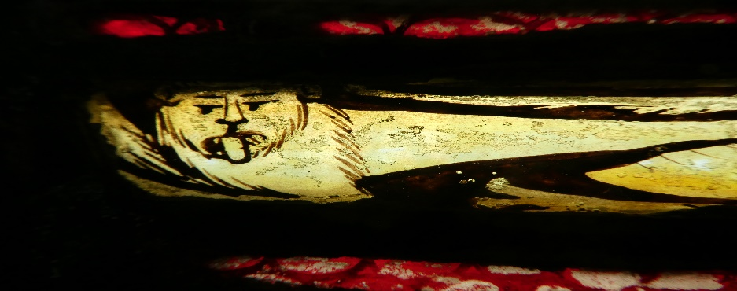

Appendix 2:

Detailed Specification for Works:

• Carefully remove perimeter mortar at head and sill of window with tungsten tipped chisel, leaving clean slots for vents.
• Prepare photographic record before, during and after conservation/restoration works.
• Prepare a pre-conservation proposal document for the window for the information of the client in line with best practice: in consultation with the client, their agent or statutory bodies as appropriate.
• Carefully dismantle the glass from the lead as necessary only to allow removal of repair leads in this case. Presume in favour of conservation/retention of original lead whenever possible.
• Clean the glass employing wet or dry methods as appropriate following test cleaning monitored by portable digital microscope.
• Repair broken pieces employing silicone edge bonds (Silcoset 153), tinted with artist’s oil colour as appropriate
• Missing fragments to be replaced where necessary with painted kiln fired pieces closely matching the original. All new insertions to be clearly date marked in kiln fired glass paint.
• Manufacture and fit new external glazing screen. (Remove and dispose of existing wire guard).
• Prepare full post conservation documentation to include written description of works, conservation diagram/s detailing interventions and photographic record.

Appendix 3:

Description of common terminology/techniques.

This description is simplistic, and intended merely to outline the techniques for the layman involved in commissioning the conservation of historic glass.
General
Stained glass usually consists of pieces of glass cut to a design, and painted with glass paint to apply detail such as drapery. The paint used is ground glass with iron oxide as a colourant. This detail is fired in a kiln at about 675° C, which fuses it to the surface of the glass.
The glass pieces are then built into panels into H-section lead “cames” soldered at every intersection. Finally the panels are weatherproofed with the application of stained glass cement; thinned linseed oil-based putty. This is traditionally applied with a bristle brush. Clearly if glass paint is frail, or if for instance medieval glass is pitted, and has been cleaned, more careful hand waterproofing should be specified.
Plain glazing or leaded lights have glass simply cut to shape and leaded into panels in the manner described above.
Glass
Is normally hand made, and of 2 types:
a) Cylinder glass - glass is blown into a cylinder shape, then cut along one side and opened in the furnace into a flat sheet.
b) Crown glass - a gather of molten glass is blown into a bubble, which is opened at one end and spun into a large disc. This is then cut into workable sheets, the central “bullion” being discarded.
These two types were in common usage from the Roman period onwards. Cylinder glass is still in production, crown glass is not.
*Note. Glass can be “flashed” - a thin layer or layers of one colour laid over another when molten. This allows the stained glass artist to employ abrading with a stone (in the medieval period) or later cutting through with acid to exploit the two or more colours.
Cutting the glass
The glass was cut in the medieval period by parting with a hot iron then nibbling or “grozing” the pieces to shape with a notched iron tool. The craftsmen achieved extraordinary results with these primitive means. A recognisable bevelled, worked edge is the hallmark of this early glass. Glass was cut with a diamond tool from the 16th. C. onwards, and is now commonly cut with a tungsten wheel.

Colour in glass
Is predominantly added to glass in the manufacture by the addition of metallic oxides to the molten glass. This is termed pot-metal glass.
The stained-glass craftsmen thus purchase coloured sheets from the glassmaker; the two disciplines have always been separate. The craftsman then cuts paints and leads the window, and fixes the completed panels in the window opening.
Applied decoration
Colour/tone can be applied and fired to surface of glass by the glass artist in 3 ways:
- Glass paint, a mixture of ground glass and metallic oxide, which is kiln fired. When well fired this is extremely durable. There are many examples of 14th. C. glass painting in excellent condition. There can be problems with painted detail however. There were problems with under firing and incorrect glass paint recipes in the 19th. C. which means that today the paint both flakes off, and is badly affected by condensation. Glass paint from the 16th/17th. C. is frequently very soft in nature and needs very cautious handling. The conservation glazier needs to show the knowledge and sensitivity to identify glass paint condition and deal with such problems.
- By the application of silver-stain to chemically colour the glass when fired in the kiln to various shades of yellow. (in common usage after the mid14th.C) This revolutionary development allowed craftsmen to use two colours within a single piece of glass.
- By the application of transparent enamel colours (not in common usage until the 16th. C) This transparent colour developed as the availability of pot metal glass waned through a combination of war, pestilence and Fashion. It allowed virtuoso glass painting, particularly suited to heraldic devices. This material fires at a lower temperature than glass paint (typically 600 C) and can flake off leaving a distinctive disturbed surface. Blue enamel is particularly prone to this problem.

The Lead Came
Was cast into slender H-section moulds in the medieval period. Some survives in-situ, and should be noted and conserved.
Latterly - since about 1500, lead has been milled through a wheeled machine to make various profiles. Characteristic mill-marks are left within the lead. It is very important that the characteristics of your glazing are noted and retained by the glazier. In particular the profile and depth of the H-section lead. There are two good reasons for this:
- If a deeper heart lead than original is employed the weight of the panels, and the relationship to any support structure is set out of balance. Panels will buckle prematurely, and the necessary work of future glaziers in dismantling the panels will be far more traumatic for the glass.
- It hardly needs saying that the profile of the lead is part of the original design. Any changes from this, especially allied to excess cement depth will fundamentally alter the texture and appearance of the glazing, and the façade of the building, especially externally.

Fixing methods and Metalwork
Completed panels of stained glass are normally set in to window openings into a groove in the stonework pointed both sides with mortar. The serious mistake of using cementitious mortar, often Portland cement has been made in the past. Only lime mortar should be employed as unlike cement based mortars it stays relatively soft and moves with the panels and surrounding stonework.
The panels sit one on top of the other at horizontal ‘divisions’, “saddled” by broad flanged leads.
At these panel divisions, and at other points, glazing bars set firmly into the stonework support the panels by the means of lead or copper ties soldered to the panels and twisted around the bars. There can be vertical bars or stanchions, set into lugs in the horizontal bars. These substantial iron support and security systems are often termed “ferramenta”.
Opening frames to allow ventilation are termed “casements.”

Deterioration of early glass and Environmental Protective Glazing
Early glass used in stained glass windows was simply made by melting sand with ash, derived from kelp (soda) or more commonly bracken or wood (potash). This glass is vulnerable to attack from moisture, predominantly in churches in the form of wetting condensation. Elements leach out of the glass, forming crusts and pitting, and in the worst cases cause holes in the glass. Unfortunately the presence of corrosion crusts can hold water on the surface exacerbating the processes of degradation. This problem is both unsightly for the present, and potentially very damaging for the longer term. EPG is a system in which vulnerable stained glass is protected from damaging cycles of condensation, airborne pollutants and the ravages of weather by the introduction of an external glazing screen. The system has been in usage for at least 65 years in Europe; one of the first installations was at Berne Minster, Germany in about 1945.
Historically in terms of the aesthetic impact the results have been varied; some installations to major buildings have been without doubt disfiguring and unfortunate, whilst some have been a great success, subtly designed and functioning well.
There are a number of possible designs for such systems; for example the stained glass can be set inside the building, away from its original glazing groove, supported in a bronze framework. The new external glazing is set in the original position of the stained glass.
In alternative systems developed at the pre-eminent European stained glass conservation studio at Cologne cathedral, and in the UK by Holy Well Glass, Wells, the stained glass remains in its original position; the new glazing screen is in this case set on the exterior of the building.
In either case the outside layer is sealed, and the warmer air from the inside of the building is introduced into the gap- the inter space, between the two layers.
The aim is to provide airflow in the inter space and thermal buffering to encourage damaging cycles of condensation onto the new external glazing screen to minimise its occurrence on the historic glass. The stained glass is also isolated from the ravages of the weather.

There are pro and contra arguments for both systems, both technical and aesthetic which are complex and outside the scope of this brief explanation. What is certain is that there is no ‘one size fits all’ system; the protective glazing must be designed for, and be appropriate for each situation.
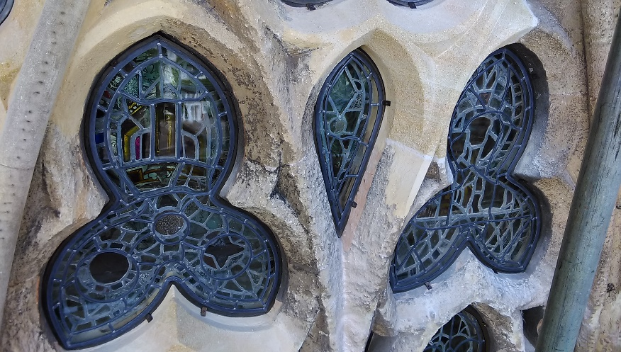
Perfectly tailored EPG frames at Exeter cathedral

The most appropriate method for this particular situation is the method detailed in the diagram below.
The stained glass remains in its original position. Vents are created at the base and apex of the window by removing mortar. (This method proved effective in a similar installation at St. Mary Redcliffe in Bristol, which was tested using sophisticated environmental monitoring equipment).
A new exterior glazing in toughened glass in four sections to correspond to positions of existing tie bars is installed outside the stained glass, set into a bronze perimeter frame edge grouted with lime mortar, accessible for maintenance.
The interspace between the stained glass and the new external glazing would be 30mm.
Such systems have been proven to work through environmental monitoring of installations and comparison with unprotected test areas. Environmental Protective Glazing is the only reliable method known to us at present to protect vulnerable works of Art in stained glass, it is at best an elegant conservation solution, functioning passively and adapting to differing environmental conditions.
Report Copyright Holy Well Glass.
Prepared by: Stephen Clare ACR. FMGP.
Holy Well Glass Ltd, Glaziers Yard, Lovers Walk, Wells, BA5 2QL

Woodforde in his ‘Stained Glass in Somerset 1250-1830 (1946) Pgs 129- 130 ‘It would seem that these shields were painted after 1434 and perhaps before Bishop Stafford’s translation to Canterbury in 1443’.

